**Introduction paragraph:** and between the eastern Bering Sea (EBS), Aleutian Islands (AI), and Gulf of Alaska (GOA) outside of their winter (January – April) spawning season. In March 2021 and 2022, a cooperative tagging study between the Alaska Fisheries Science Center (AFSC) and the Aleutian East Borough (AEB) was initiated to examine the seasonal movements of Pacific cod captured in the western GOA during the winter spawning season. The goal of this study was to better understand the seasonal connectivity between winter spawning locations of Pacific cod in the western GOA and foraging locations in GOA and EBS during the summer months when both Alaska Fisheries Science Center's bottom-trawl surveys are conducted. In March 2021, Pacific cod were tagged and released with 25 pop-up satellite tags and 957 conventional tags within 8 subareas of the western GOA near Shumagin and Sanak Islands in 2021 (Fig. 2.2). In April 2022, Pacific cod with 27 pop-up satellite tags were released along with 760 conventional tags in several of the same subareas as in 2021. Pop-up satellite tags will release and transmit data to satellites at predetermined lengths of time (e.g. 180 days), whereas conventional tags require a platform of recovery such as a fishery. In 2021, pop-up locations of satellite tagged Pacific cod within 3 months of release were largely located within the vicinity of the release areas (March-May). However, more than half the fish with tags recovered between June through October (10 of 17 satellite-tagged fish with summer recovery locations) had moved substantial distances into the EBS, AI, northern Bering Sea (NBS), Russia, and the Chukchi Sea. These results contrasted with Pacific cod movement in 2022, where from June through October only 3 out of 23 satellite-tagged fish with summer recovery locations moved into the EBS (n=2) and NBS (n=1) and most fish stayed close to their original spawning areas. These movement patterns suggest seasonal connectivity between the western GOA and other management regions, such as the EBS, but with an unknown amount of interannual variability in these movement patterns. The research has also provided insights into resident vs. migratory fish. Some tagged fish are still at large with winter 2023 pop-up dates. Work is in progress to reconstruct movement paths of individual fish with a geolocation model which will provide valuable information on migration timing and pathways. Additional satellite and conventional tag releases are planned for March 2023.

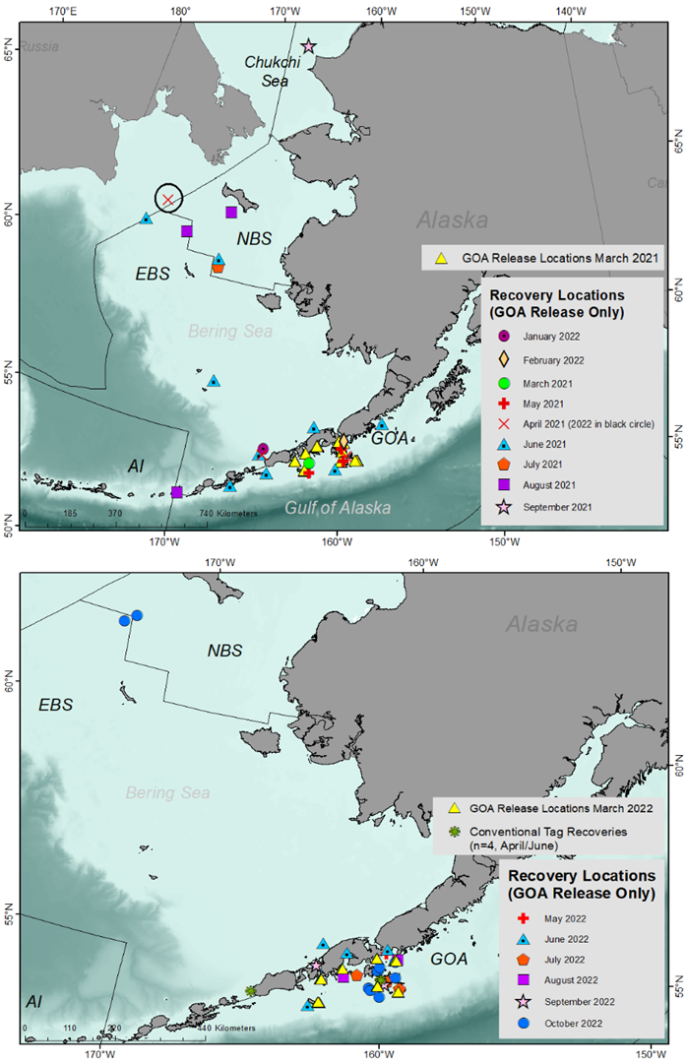

##### Figure 2.2. Popup satellite tag releases for March 2021/2022 (yellow triangles) and monthly tag recovery locations for 2021 (top) and 2022 (bottom) by region (NBS = Northern Bering Sea, EBS = Eastern Bering Sea, AI = Aleutian Islands, and GOA = Gulf of Alaska).